

Practices for Secure Software Report

Table of Contents
Document Revision History 3
Client 3
Instructions 3
Developer 4
1. Algorithm Cipher 4
2. Certificate Generation 4
3. Deploy Cipher 4
4. Secure Communications 4
5. Secondary Testing 4
6. Functional Testing 4
7. Summary 4
8. Industry Standard Best Practices 4

Document Revision History

Version | Date | Author | Comments
1.0 | 04/17/2025 | Jessica Johnson | CS305 Software Security

Client



Developer
Jessica Johnson

Algorithm Cipher

For Artemis Financials’ software security needs, I would recommend using SHA-256. SHA-256, short for secure hash algorithm, is a hash algorithm designed to generate and verify check sums. Check sums detect tampering or corruption in data which is especially important for public-facing web applications like Artemis Financials. SHA-256 is world renowned for its security features. (Gitlan, 2025) It has multiple cryptographic properties that support its security features, like collision resistance. This ensures that every unique input has a unique hash. Without this collision resistance, it would be possible to forge data. Even the United States Government mandates the usage of SHA-256 for their highest valued secrets and assets. (Gitlan, 2025)
As mentioned before, SHA-256 generates a 256-bit checksum. It takes data input of any size and creates an output that is exactly 256 bits long which is a 64-character hexadecimal string or a 32-byte checksum. (Gitlan, 2025) The longer the bit length the less vulnerable the data is to attack. Often, that vulnerability can be a collision. A collision occurs when two different keys are assigned to the same hash value. This can lead to overwriting or incorrect data retrieval. (TP, 2024)
SHA-256 is a hash function, not an encryption method. Encryption works by scrambling data with a key and then using that same key to unscramble it when you need it. The SHA-256 hash function doesn’t lock its data with a key, instead it creates a 64-character string that cannot be decrypted. One slight change in the input results in a whole new output which makes data change verification easier to detect.
Encryption has been around since ancient times. Theres even a cipher named after Caesar himself wherein letters are shifted a fixed number of positions down the alphabet. (Ward) This shows even early civilizations understood the importance of securing our private data. Since Caesar, encryption has evolved. Advanced Encryption Standards (AES), RSA, and Hash Functions are all the current and trusted encryption and hashing algorithms.(Ward) No matter the techniques used to protect your private data, it is important to keep current and use the most secure option.

Certificate Generation

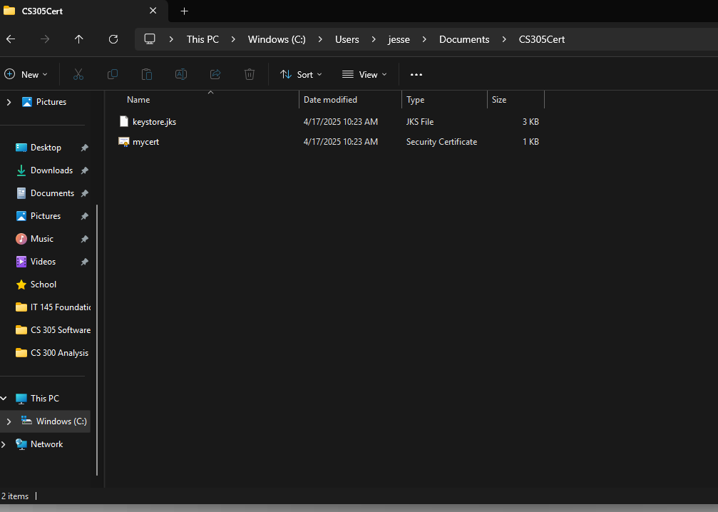

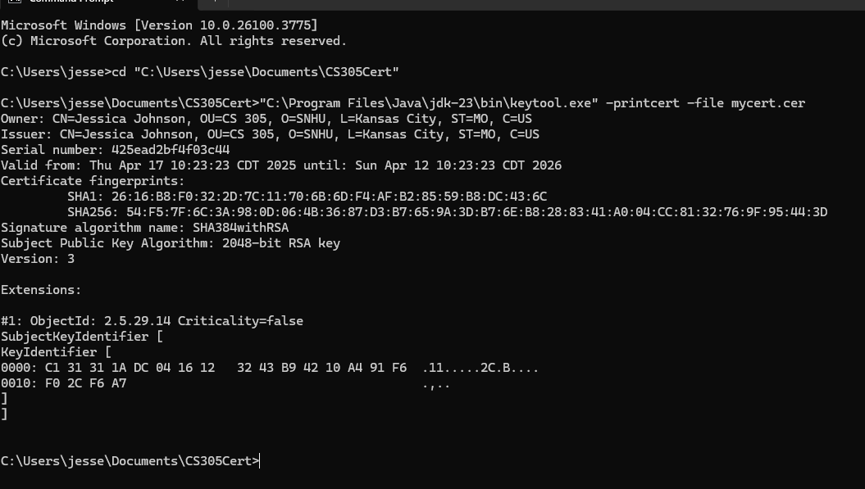

Deploy Cipher

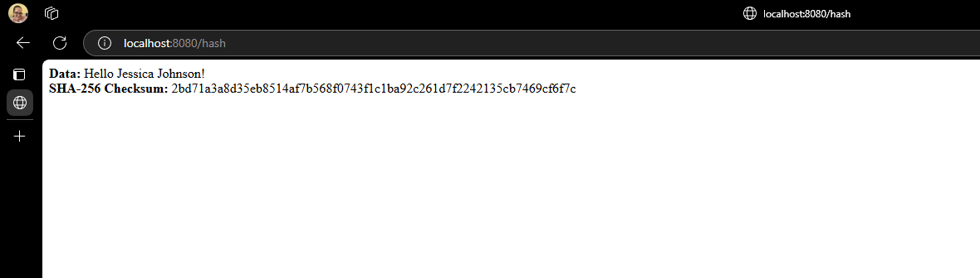

Secure Communications

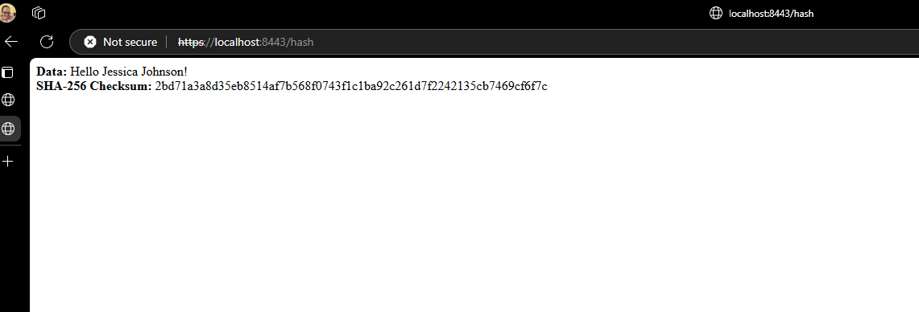

Secondary Testing

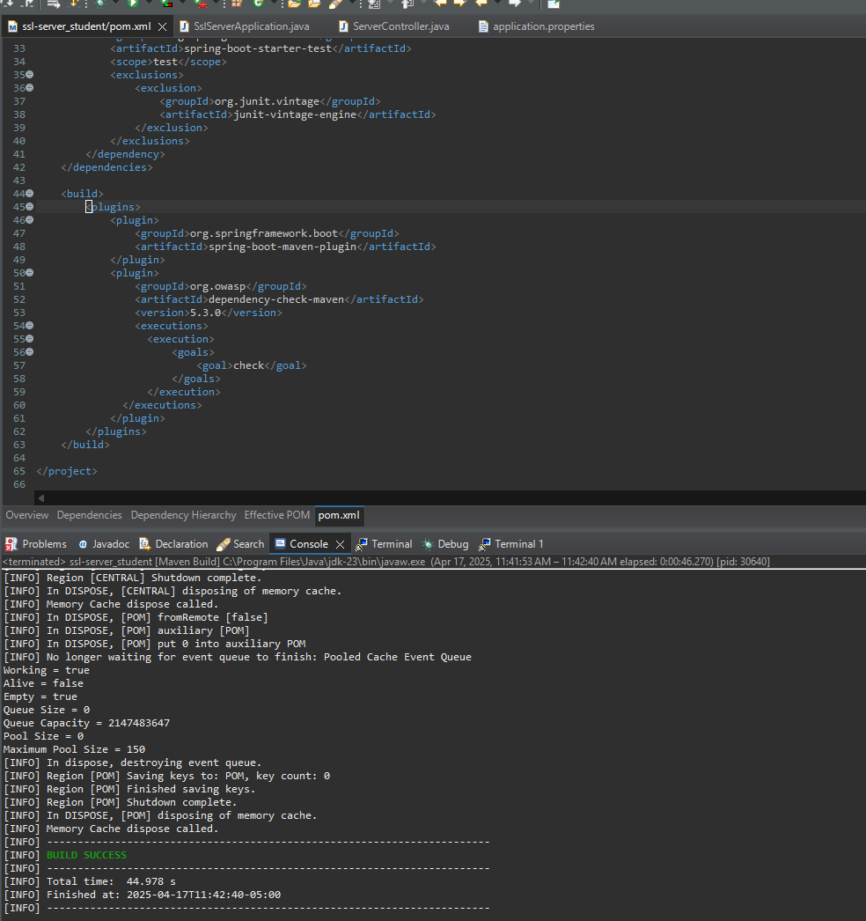

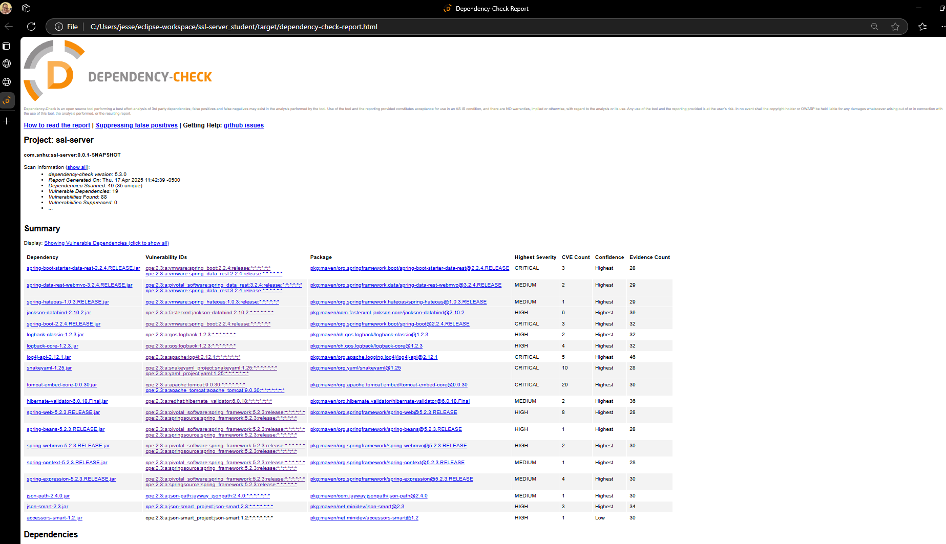

Functional Testing





Summary

We focused on strengthening the security of Artemis Financials’ public web interface by applying secure software development practices. A secure RESTful web service was created using Spring Boot paired with HTTPS encryption and checksum functionality. We used SHA-256 hash function to verify the integrity of the data. A secure communication line was created via encryption and a self-signed certificate was generated.
The codebase was refactored to remove any insecure configurations. The checksum was encapsulated within a dedicated controller which gave way to improved readability and isolated business functions. Static testing was done with the OWASDP dependency check Maven plug in. This scanned the project for vulnerabilities. 88 Vulnerabilities were found within 19 dependencies.
This solution ensures a production-ready application that includes secure coding practices, encrypted communications, and a proactive approach to vulnerabilities. Identification, analysis, prioritization, and verification were all steps followed from the Vulnerability Assessment Process Flow Diagram. Multiple layers of security like encrypted HTTPS communication, SHA-256 checksums, and extensive vulnerability scanning. Layering your security measures makes it very hard for intruders to penetrate to the private data that we are trying so hard to keep private.

Industry Standard Best Practices

Throughout the entire process, industry standard best practices have been used. By using SHA-256, a hashing algorithm, we ensured secure data movement and communication. SHA-256 is approved by the National Institute of Standards and Technology (NIST). We also used static analysis by using the OWASP Dependency-Check Maven plugin scans for vulnerabilities. A self-signed certificate awas also integrated with the applications build path, avoid hardcoded vulnerabilities.
An agile Software Development approach was used during this project. Secure Software Development Lifecycle emphasized early and continual security measures through development. All these layers of development with security in mind, ensure Artemis Financial application is being protected by the most current and effective software security.

References

Gitlan, D. (2025, March 28). What is the SHA-256 Algorithm & How It Works. SSL Dragon. https://www.ssldragon.com/blog/sha-256-algorithm/

TP, V. (2024, February 1). Understanding Hash Collisions: How They Occur and How to Handle Them. Codiin. https://codiin.com/understanding-hash-collisions-how-they-occur-and-how-to-handle-them/

Ward, T. (n.d.). The Evolution of Encryption: Past, Present, and Future. SPYRUS. Retrieved April 17, 2025, from https://spyrus.com/the-evolution-of-encryption-past-present-and-future/

